SOLUCIONS

GENE IDH2
IDH2 (ENST00000330062.8)
WILD TYPE DNA IDH2
Nucleotide Sequence (1359 nt):
>IDH2
ATGGCCGGCTACCTGCGGGTCGTGCGCTCGCTCTGCAGAGCCTCAGGCTCGCGGCCGGCCTGGGCGCCGG
CGGCCCTGACAGCCCCCACCTCGCAAGAGCAGCCGCGGCGCCACTATGCCGACAAAAGGATCAAGGTGGC
GAAGCCCGTGGTGGAGATGGATGGTGATGAGATGACCCGTATTATCTGGCAGTTCATCAAGGAGAAGCTC
ATCCTGCCCCACGTGGACATCCAGCTAAAGTATTTTGACCTCGGGCTCCCAAACCGTGACCAGACTGATG
ACCAGGTCACCATTGACTCTGCACTGGCCACCCAGAAGTACAGTGTGGCTGTCAAGTGTGCCACCATCAC
CCCTGATGAGGCCCGTGTGGAAGAGTTCAAGCTGAAGAAGATGTGGAAAAGTCCCAATGGAACTATCCGG
AACATCCTGGGGGGGACTGTCTTCCGGGAGCCCATCATCTGCAAAAACATCCCACGCCTAGTCCCTGGCT
GGACCAAGCCCATCACCATTGGCAGGCACGCCCATGGCGACCAGTACAAGGCCACAGACTTTGTGGCAGA
CCGGGCCGGCACTTTCAAAATGGTCTTCACCCCAAAAGATGGCAGTGGTGTCAAGGAGTGGGAAGTGTAC
AACTTCCCCGCAGGCGGCGTGGGCATGGGCATGTACAACACCGACGAGTCCATCTCAGGTTTTGCGCACA
GCTGCTTCCAGTATGCCATCCAGAAGAAATGGCCGCTGTACATGAGCACCAAGAACACCATACTGAAAGC
CTACGATGGGCGTTTCAAGGACATCTTCCAGGAGATCTTTGACAAGCACTATAAGACCGACTTCGACAAG
AATAAGATCTGGTATGAGCACCGGCTCATTGATGACATGGTGGCTCAGGTCCTCAAGTCTTCGGGTGGCT
TTGTGTGGGCCTGCAAGAACTATGACGGAGATGTGCAGTCAGACATCCTGGCCCAGGGCTTTGGCTCCCT
TGGCCTGATGACGTCCGTCCTGGTCTGCCCTGATGGGAAGACGATTGAGGCTGAGGCCGCTCATGGGACC
GTCACCCGCCACTATCGGGAGCACCAGAAGGGCCGGCCCACCAGCACCAACCCCATCGCCAGCATCTTTG
CCTGGACACGTGGCCTGGAGCACCGGGGGAAGCTGGATGGGAACCAAGACCTCATCAGGTTTGCCCAGAT
GCTGGAGAAGGTGTGCGTGGAGACGGTGGAGAGTGGAGCCATGACCAAGGACCTGGCGGGCTGCATTCAC
GGCCTCAGCAATGTGAAGCTGAACGAGCACTTCCTGAACACCACGGACTTCCTCGACACCATCAAGAGCA
ACCTGGACAGAGCCCTGGGCAGGCAGTAG
Translation (452 aa):
>IDH2
MAGYLRVVRSLCRASGSRPAWAPAALTAPTSQEQPRRHYADKRIKVAKPVVEMDGDEMTRIIWQFIKEKL
ILPHVDIQLKYFDLGLPNRDQTDDQVTIDSALATQKYSVAVKCATITPDEARVEEFKLKKMWKSPNGTIR
NILGGTVFREPIICKNIPRLVPGWTKPITIGRHAHGDQYKATDFVADRAGTFKMVFTPKDGSGVKEWEVY
NFPAGGVGMGMYNTDESISGFAHSCFQYAIQKKWPLYMSTKNTILKAYDGRFKDIFQEIFDKHYKTDFDK
NKIWYEHRLIDDMVAQVLKSSGGFVWACKNYDGDVQSDILAQGFGSLGLMTSVLVCPDGKTIEAEAAHGT
VTRHYREHQKGRPTSTNPIASIFAWTRGLEHRGKLDGNQDLIRFAQMLEKVCVETVESGAMTKDLAGCIH
GLSNVKLNEHFLNTTDFLDTIKSNLDRALGRQ

TUMOR DNA (Bone Marrow)
Nucleotide Sequence (1359 nt):
>IDH2
ATGGCCGGCTACCTGCGGGTCGTGCGCTCGCTCTGCAGAGCCTCAGGCTCGCGGCCGGCCTGGGCGCCGG
CGGCCCTGACAGCCCCCACCTCGCAAGAGCAGCCGCGGCGCCACTATGCCGACAAAAGGATCAAGGTGGC
GAAGCCCGTGGTGGAGATGGATGGTGATGAGATGACCCGTATTATCTGGCAGTTCATCAAGGAGAAGCTC
ATCCTGCCCCACGTGGACATCCAGCTAAAGTATTTTGACCTCGGGCTCCCAAACCGTGACCAGACTGATG
ACCAGGTCACCATTGACTCTGCACTGGCCACCCAGAAGTACAGTGTGGCTGTCAAGTGTGCCACCATCAC
CCCTGATGAGGCCCGTGTGGAAGAGTTCAAGCTGAAGAAGATGTGGAAAAGTCCCAATGGAACTATCCGG
AACATCCTGGGGGGGACTGTCTTCCGGGAGCCCATCATCTGCAAAAACATCCCACGCCTAGTCCCTGGCT
GGACCAAGCCCATCACCATTGGCAAGCACGCCCATGGCGACCAGTACAAGGCCACAGACTTTGTGGCAGA
CCGGGCCGGCACTTTCAAAATGGTCTTCACCCCAAAAGATGGCAGTGGTGTCAAGGAGTGGGAAGTGTAC
AACTTCCCCGCAGGCGGCGTGGGCATGGGCATGTACAACACCGACGAGTCCATCTCAGGTTTTGCGCACA
GCTGCTTCCAGTATGCCATCCAGAAGAAATGGCCGCTGTACATGAGCACCAAGAACACCATACTGAAAGC
CTACGATGGGCGTTTCAAGGACATCTTCCAGGAGATCTTTGACAAGCACTATAAGACCGACTTCGACAAG
AATAAGATCTGGTATGAGCACCGGCTCATTGATGACATGGTGGCTCAGGTCCTCAAGTCTTCGGGTGGCT
TTGTGTGGGCCTGCAAGAACTATGACGGAGATGTGCAGTCAGACATCCTGGCCCAGGGCTTTGGCTCCCT
TGGCCTGATGACGTCCGTCCTGGTCTGCCCTGATGGGAAGACGATTGAGGCTGAGGCCGCTCATGGGACC
GTCACCCGCCACTATCGGGAGCACCAGAAGGGCCGGCCCACCAGCACCAACCCCATCGCCAGCATCTTTG
CCTGGACACGTGGCCTGGAGCACCGGGGGAAGCTGGATGGGAACCAAGACCTCATCAGGTTTGCCCAGAT
GCTGGAGAAGGTGTGCGTGGAGACGGTGGAGAGTGGAGCCATGACCAAGGACCTGGCGGGCTGCATTCAC
GGCCTCAGCAATGTGAAGCTGAACGAGCACTTCCTGAACACCACGGACTTCCTCGACACCATCAAGAGCA
ACCTGGACAGAGCCCTGGGCAGGCAGTAG
CDS mutation c.515G>A (Substitution, position 515, G➞A)

Translation (452 aa):
>IDH2
MAGYLRVVRSLCRASGSRPAWAPAALTAPTSQEQPRRHYADKRIKVAKPVVEMDGDEMTRIIWQFIKEKL
ILPHVDIQLKYFDLGLPNRDQTDDQVTIDSALATQKYSVAVKCATITPDEARVEEFKLKKMWKSPNGTIR
NILGGTVFREPIICKNIPRLVPGWTKPITIGKHAHGDQYKATDFVADRAGTFKMVFTPKDGSGVKEWEVY
NFPAGGVGMGMYNTDESISGFAHSCFQYAIQKKWPLYMSTKNTILKAYDGRFKDIFQEIFDKHYKTDFDK
NKIWYEHRLIDDMVAQVLKSSGGFVWACKNYDGDVQSDILAQGFGSLGLMTSVLVCPDGKTIEAEAAHGT
VTRHYREHQKGRPTSTNPIASIFAWTRGLEHRGKLDGNQDLIRFAQMLEKVCVETVESGAMTKDLAGCIH
GLSNVKLNEHFLNTTDFLDTIKSNLDRALGRQ
AA mutation p.R172K (Substitution - Missense, position 172, R➞K)

GENE NRAS

WILD TYPE DNA NRAS
NRAS (ENST00000369535.5)
Nucleotide Sequence (570 nt):
>NRAS
ATGACTGAGTACAAACTGGTGGTGGTTGGAGCAGGTGGTGTTGGGAAAAGCGCACTGACAATCCAGCTAA
TCCAGAACCACTTTGTAGATGAATATGATCCCACCATAGAGGATTCTTACAGAAAACAAGTGGTTATAGA
TGGTGAAACCTGTTTGTTGGACATACTGGATACAGCTGGACAAGAAGAGTACAGTGCCATGAGAGACCAA
TACATGAGGACAGGCGAAGGCTTCCTCTGTGTATTTGCCATCAATAATAGCAAGTCATTTGCGGATATTA
ACCTCTACAGGGAGCAGATTAAGCGAGTAAAAGACTCGGATGATGTACCTATGGTGCTAGTGGGAAACAA
GTGTGATTTGCCAACAAGGACAGTTGATACAAAACAAGCCCACGAACTGGCCAAGAGTTACGGGATTCCA
TTCATTGAAACCTCAGCCAAGACCAGACAGGGTGTTGAAGATGCTTTTTACACACTGGTAAGAGAAATAC
GCCAGTACCGAATGAAAAAACTCAACAGCAGTGATGATGGGACTCAGGGTTGTATGGGATTGCCATGTGT
GGTGATGTAA
Translation (189 aa):
>NRAS
MTEYKLVVVGAGGVGKSALTIQLIQNHFVDEYDPTIEDSYRKQVVIDGETCLLDILDTAGQEEYSAMRDQ
YMRTGEGFLCVFAINNSKSFADINLYREQIKRVKDSDDVPMVLVGNKCDLPTRTVDTKQAHELAKSYGIP
FIETSAKTRQGVEDAFYTLVREIRQYRMKKLNSSDDGTQGCMGLPCVVM

TUMOR
Nucleotide Sequence (570 nt):
>NRAS
ATGACTGAGTACAAACTGGTGGTGGTTGGAGCAGGTGGTGTTGGGAAAAGCGCACTGACAATCCAGCTAA
TCCAGAACCACTTTATAGATGAATATGATCCCACCATAGAGGATTCTTACAGAAAACAAGTGGTTATAGA
TGGTGAAACCTGTTTGTTGGACATACTGGATACAGCTGGACAAGAAGAGTACAGTGCCATGAGAGACCAA
TACATGAGGACAGGCGAAGGCTTCCTCTGTGTATTTGCCATCAATAATAGCAAGTCATTTGCGGATATTA
ACCTCTACAGGGAGCAGATTAAGCGAGTAAAAGACTCGGATGATGTACCTATGGTGCTAGTGGGAAACAA
GTGTGATTTGCCAACAAGGACAGTTGATACAAAACAAGCCCACGAACTGGCCAAGAGTTACGGGATTCCA
TTCATTGAAACCTCAGCCAAGACCAGACAGGGTGTTGAAGATGCTTTTTACACACTGGTAAGAGAAATAC
GCCAGTACCGAATGAAAAAACTCAACAGCAGTGATGATGGGACTCAGGGTTGTATGGGATTGCCATGTGT
GGTGATGTAA
CDS mutation c.85G>A (Substitution, position 85, G➞A)

Translation (189 aa):
>NRAS
MTEYKLVVVGAGGVGKSALTIQLIQNHFIDEYDPTIEDSYRKQVVIDGETCLLDILDTAGQEEYSAMRDQ
YMRTGEGFLCVFAINNSKSFADINLYREQIKRVKDSDDVPMVLVGNKCDLPTRTVDTKQAHELAKSYGIP
FIETSAKTRQGVEDAFYTLVREIRQYRMKKLNSSDDGTQGCMGLPCVVM
AA mutation p.V29I (Substitution - Missense, position 29, V➞I)

Polyphen2:

NRAS:
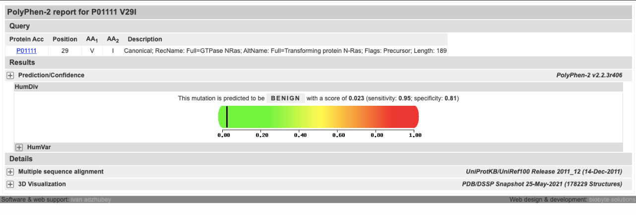
IDH2:
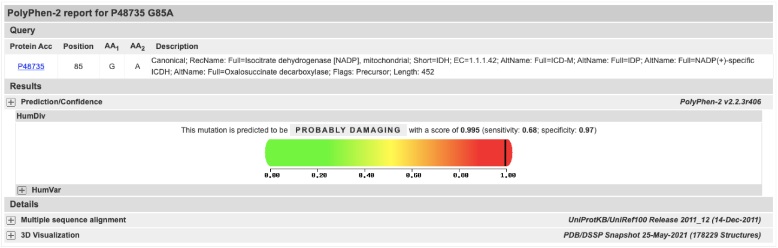

cBioPortal:

IDH2:

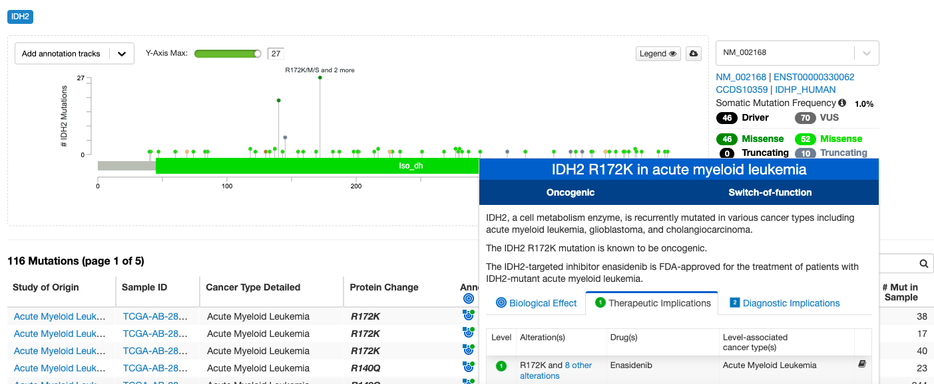
Si hacemos click en annotations nos indica que hay un fármaco dirigido contra esta mutación para el tratamiento de pacientes con AML.

